**FRONT END ENGINEERING-II**

Project Report

Semester-IV(Batch-2022)

**MOTCLUB**



**Supervised By: Submitted By:**

Mr. Raveesh Sankaria Sneha Pal

2210990996(G13)

**Department of Computer Science and Engineering**

**Chitkara University Institute of Engineering & Technology, Chitkara University, Punjab**

**Abstract**

This project report outlines the creation of a front-end website for an agency, utilizing HTML and CSS. The website encompasses essential agency information, team profiles, service packages, portfolio displays, and contact details. With a focus on user engagement and seamless navigation, the website aims to effectively communicate the agency's offerings and expertise to potential clients. Through responsive design and accessibility considerations, the project underscores the agency's commitment to delivering exceptional digital experiences.

**Table Of Content**

|  |  |  |
| --- | --- | --- |
| **Sr No.** | **Section** | **Page No.** |
| **1.** | Introduction | 4 |
| **2.** | Problem Statement | 5 |
| **3.** | Technical Details | 7 |
| **4.** | File Structure | 8 |
| **5.** | Result | 9 |
| **6.** | References | 22 |

**Introduction**

In today's digital age, a strong online presence is essential for businesses to effectively showcase their services and connect with their target audience. As such, the creation of a visually appealing and user-friendly website is paramount, particularly for design agencies looking to highlight their creativity and expertise in the competitive industry landscape. This report documents the development and implementation of a front-end website for a design agency, utilizing a combination of HTML and CSS.

The website serves as a digital storefront for the agency, offering visitors a comprehensive glimpse into its services, team members, portfolio, and contact information. Through strategic design choices and seamless user experience, the website aims to engage visitors and convey the agency's unique brand identity and capabilities effectively.

This introduction provides an overview of the project's objectives, emphasizing the importance of a well-crafted website in today's digital marketplace. Subsequent sections will delve into the technical aspects of the website development process, highlighting key features, design considerations, and implementation strategies. Additionally, the report will discuss the challenges encountered during the project and the solutions devised to overcome them, offering valuable insights for future website development endeavours. Ultimately, this project serves as a testament to the intersection of design and technology, showcasing the agency's commitment to delivering exceptional digital experiences to its clients and stakeholders.

**Problem Statement**

In the realm of design agencies, establishing a compelling online presence is crucial for attracting prospective clients and showcasing the agency's unique offerings and capabilities. However, creating a front-end website that effectively communicates the agency's brand identity, services, and portfolio while ensuring a seamless user experience poses several challenges.

Firstly, design agencies often struggle to strike the right balance between creativity and functionality in their websites. While it's essential to showcase the agency's creative flair through visually stunning designs, it's equally important to ensure that the website is easy to navigate and provides clear, concise information to visitors.

Secondly, designing a responsive website that adapts seamlessly to various devices and screen sizes presents a significant challenge. With the proliferation of mobile devices and tablets, users expect a consistent and optimized browsing experience across all platforms. Failure to deliver this can result in a loss of potential clients and credibility for the agency.

Additionally, ensuring accessibility for all users, including those with disabilities, is another pressing concern. Design agencies must adhere to accessibility standards to ensure that their websites are usable by individuals with diverse needs, such as screen readers for visually impaired users.

In summary, the problem statement revolves around the need to create a front-end website for a design agency that effectively balances creativity with functionality, offers seamless responsiveness across devices, adheres to accessibility standards, and optimizes performance to provide an exceptional user experience. Addressing these challenges will be critical in achieving the project's objectives and ensuring the success of the agency's online presence.

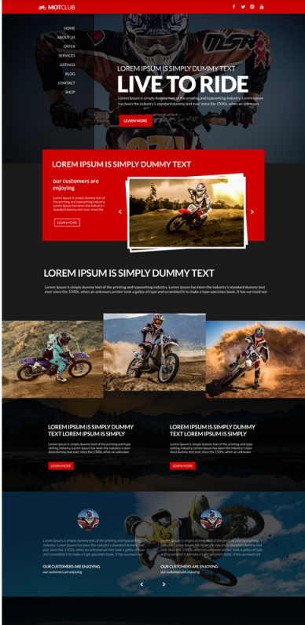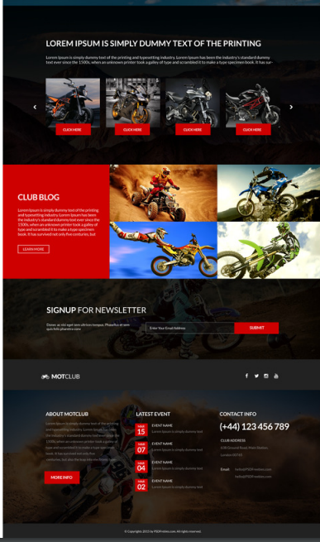

**Technical Details**

The front-end website for the design agency was constructed with a minimalist approach, employing only essential technologies to ensure a streamlined user experience. Here are the primary technical details of the project:

* **HTML Structure:** The website's structure was crafted using semantic HTML mark up to enhance accessibility and clarity. Each page was organized with appropriate tags to facilitate straightforward navigation and readability.
* **CSS Styling:** Cascading Style Sheets (CSS) were utilized for styling the website's layout, typography, and color schemes. Custom CSS rules were applied to maintain a consistent visual design across the site while optimizing load times and code simplicity.
* **Responsive Design:** Responsive design principles were implemented to ensure the website's compatibility with various devices and screen sizes. Media queries and flexible layouts were employed to adapt the content and design elements responsively without reliance on frameworks.

**File Structure**

* **m.html:** This file serves as the main entry point for the website. It contains the HTML mark-up defining the structure and content of the web pages. Within this file, sections such as the header, navigation bar, main content area, footer, and any additional elements are defined.
* **m.css:** The CSS file contains the styling rules that dictate the visual presentation of the website. This includes defining colours, fonts, layout properties, and any other stylistic elements. Selectors within this file target specific HTML elements or classes to apply the desired styles.
* **image folder:** This folder contains all the images used throughout the website. Images may include logos, background images, or any other visual assets required to enhance the design and content presentation. Proper organization within this folder helps maintain the clarity and accessibility of image resources.
* **PSD file:** This PSD (Photoshop Document) file contains the original design mock up created using Adobe Photoshop. While not directly utilized in the website's development, it serves as a reference for design elements, layout, and visual styling.

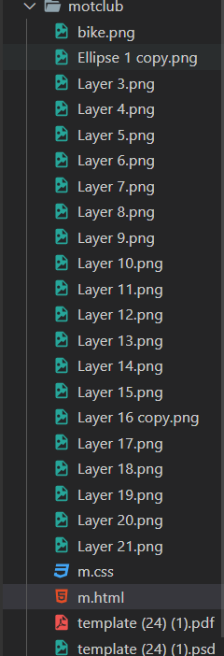

**Result**

**Website Screenshots:-**

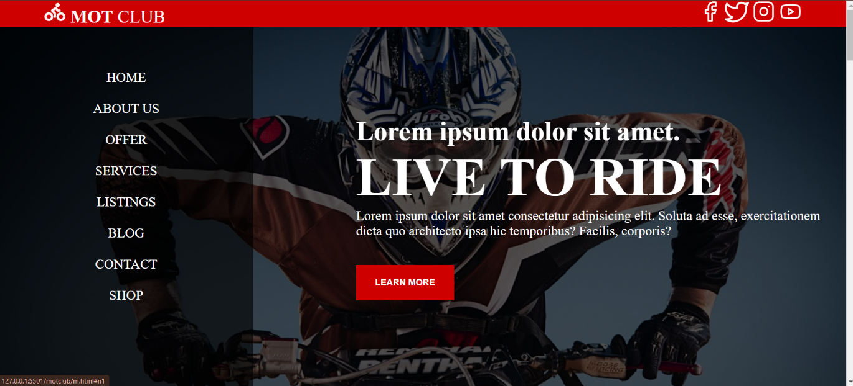

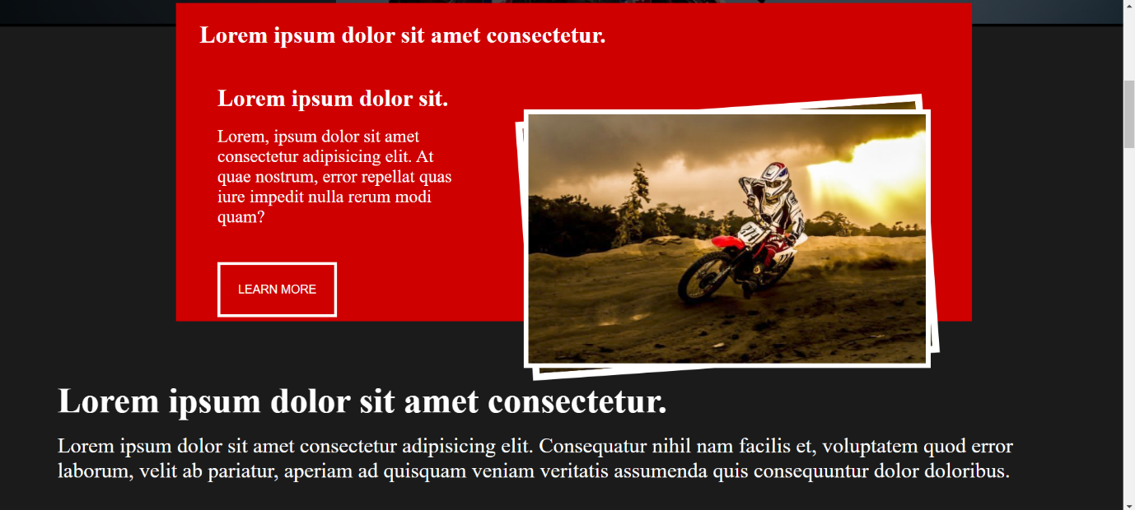

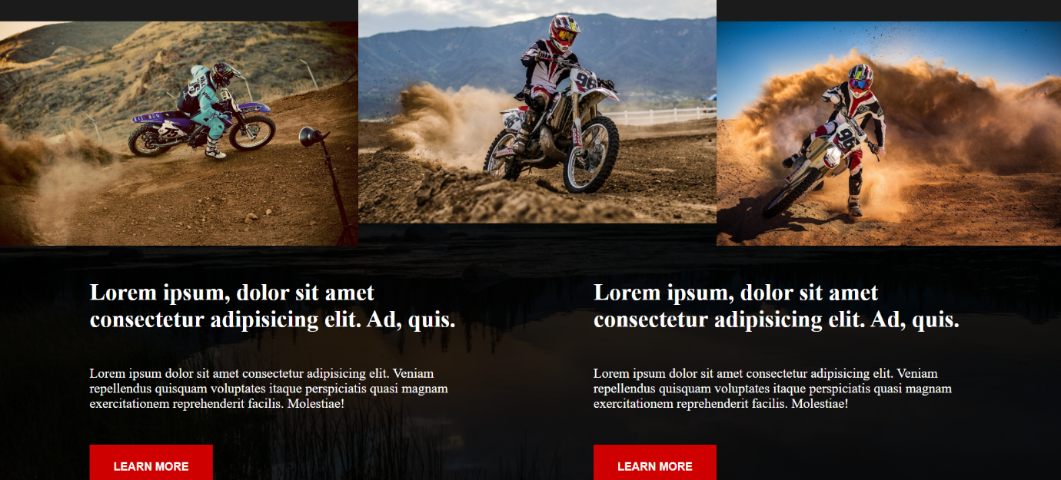

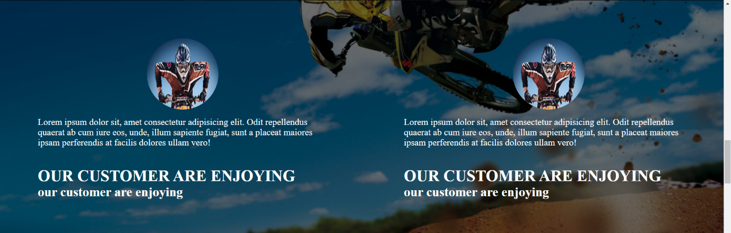

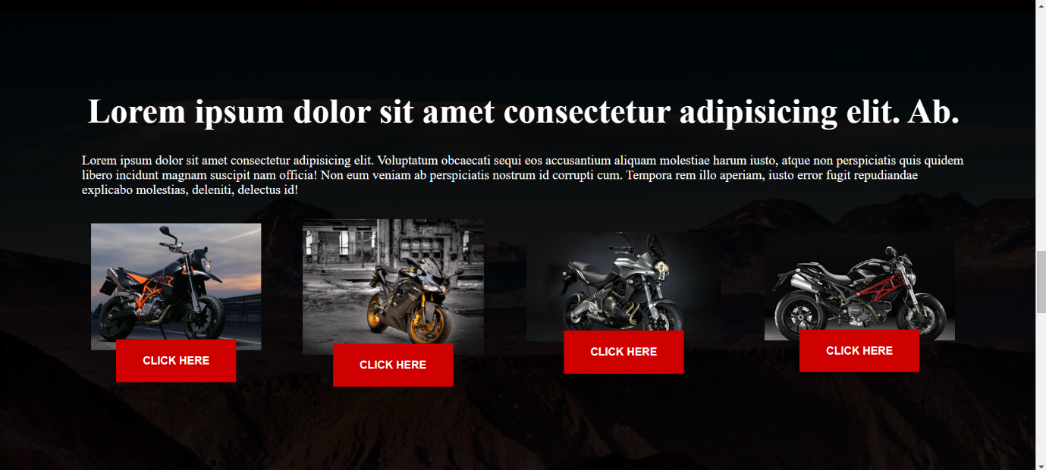

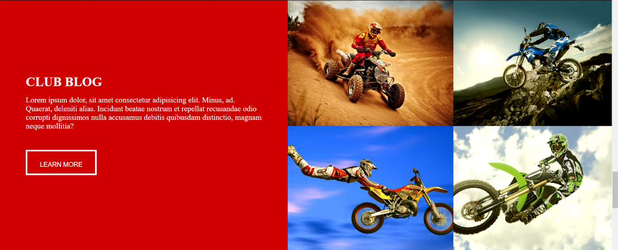

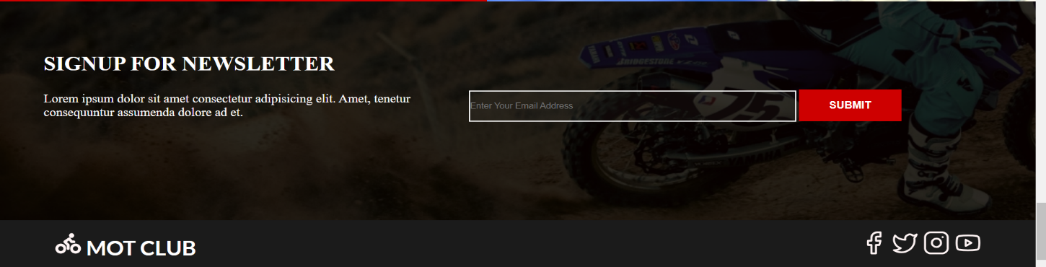

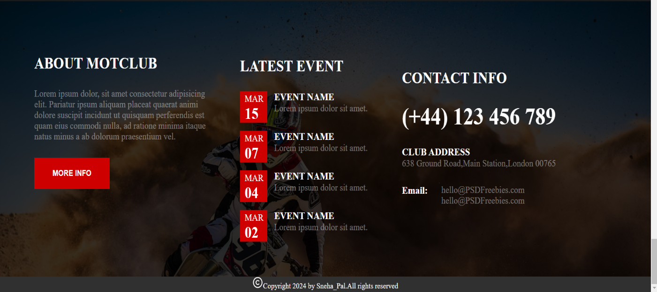

**Code:-**

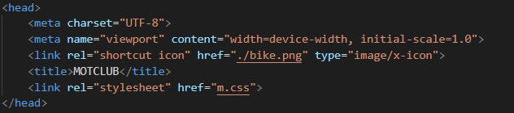**--HEAD--**

**--BODY--**

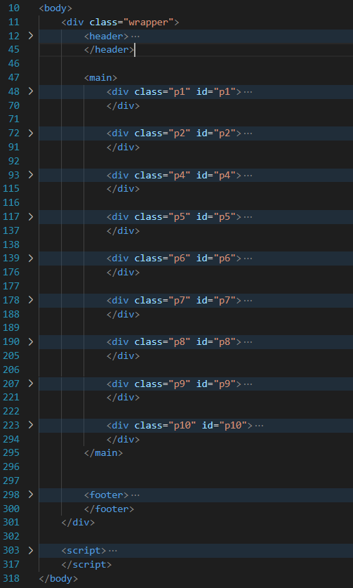

**--HEADER--**

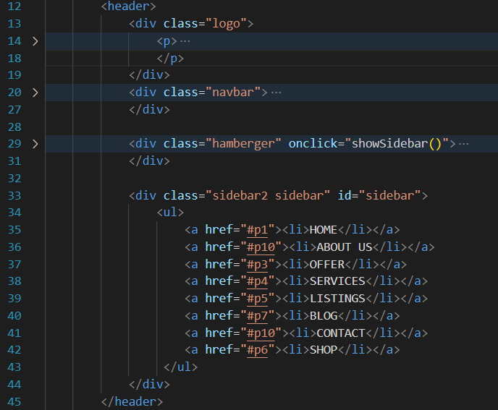

**--DIV1(home page)—**

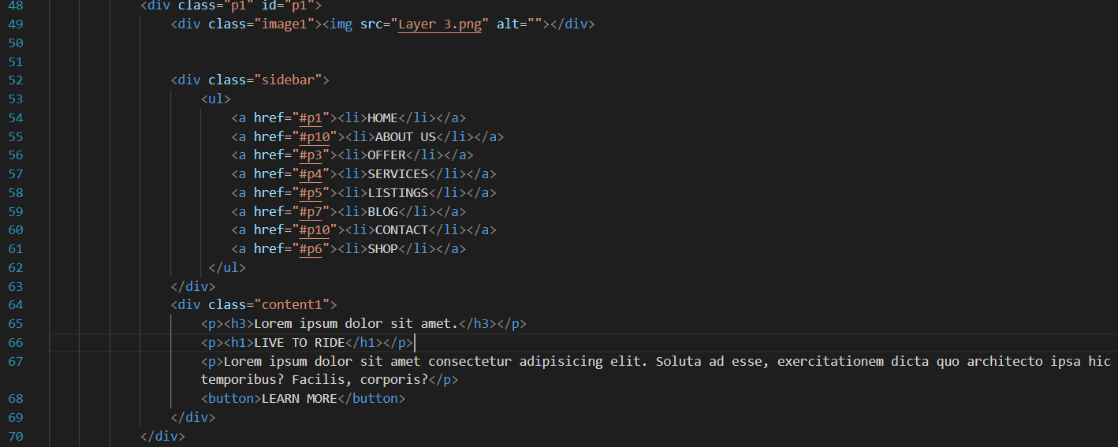

**--DIV2(page 2+3)—**

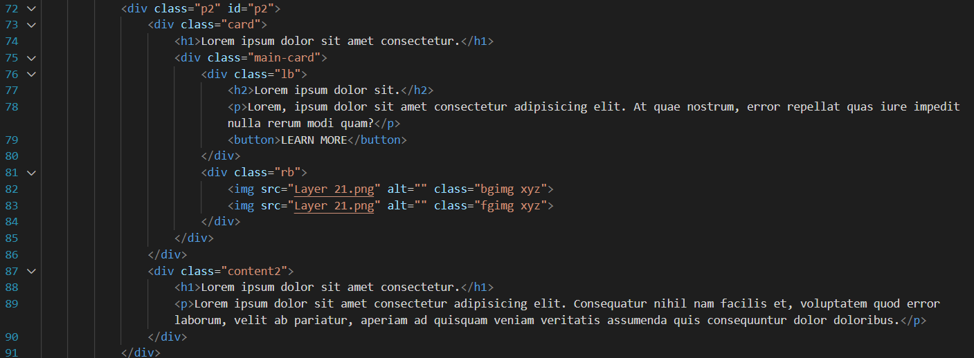

**--DIV4(services)—**

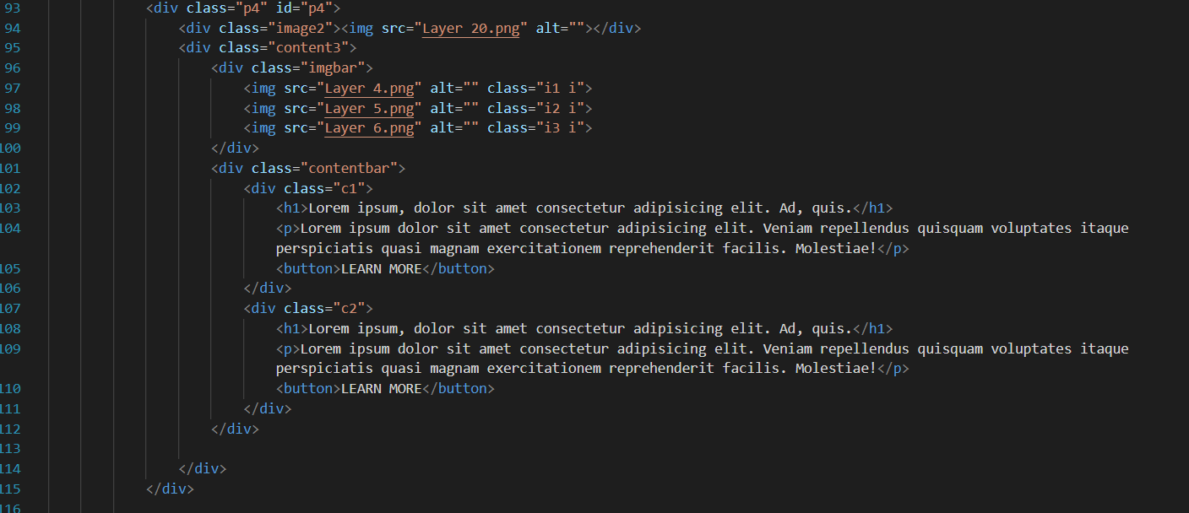

**--DIV5(listing)—**

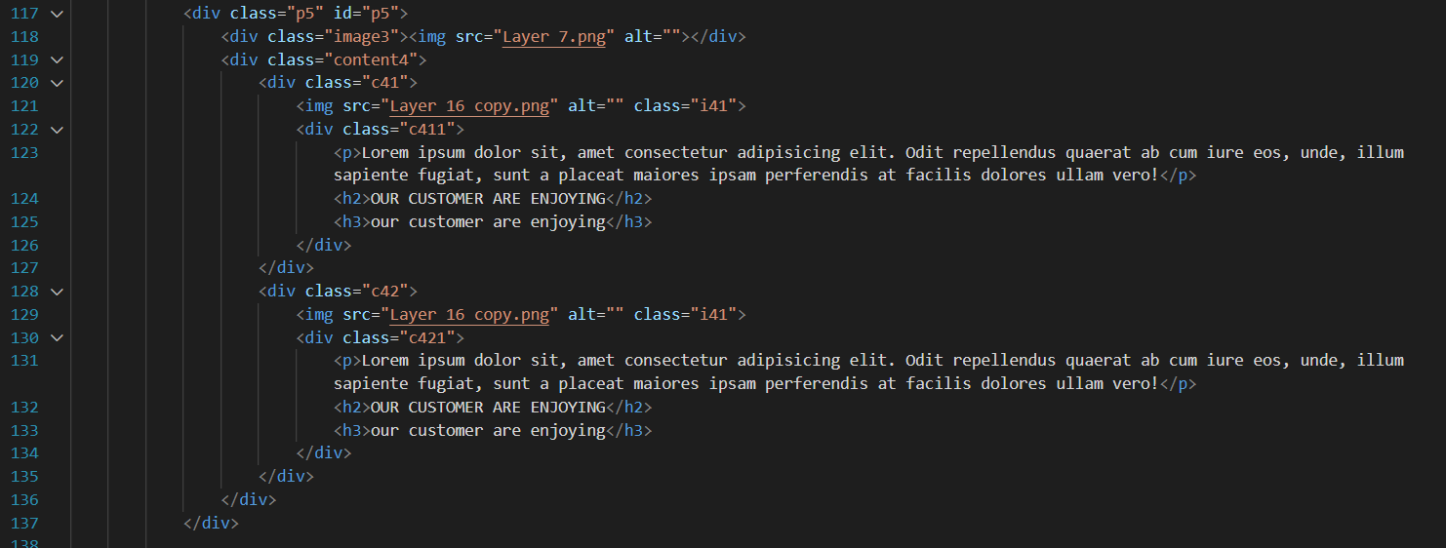

**--DIV6(shop)—**

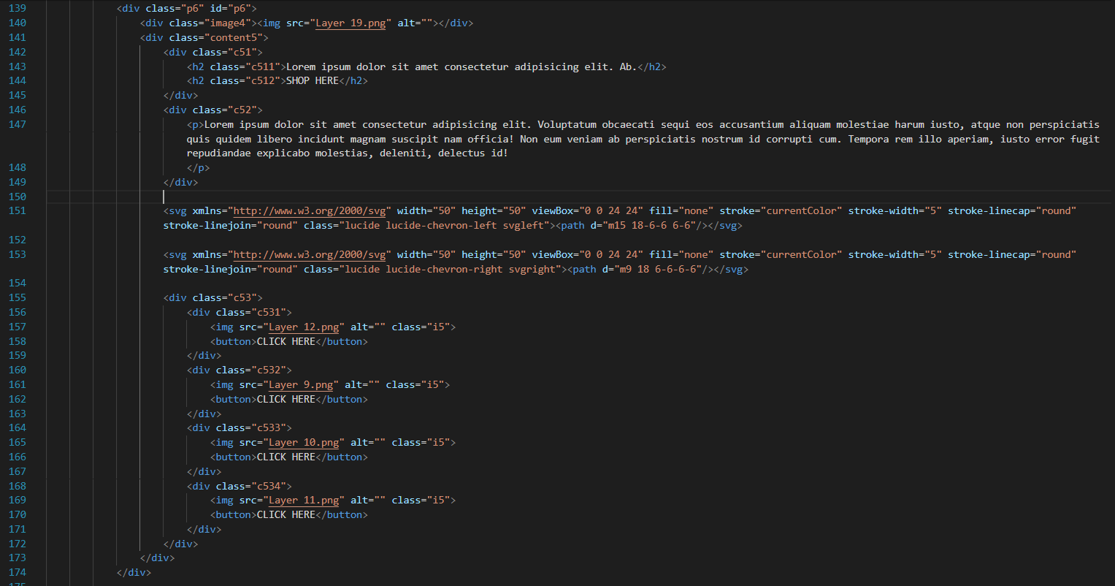

**-- DIV7(blog)—**

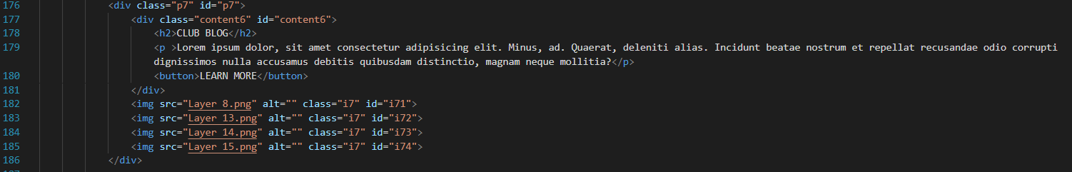

**-- DIV8(signup)—**

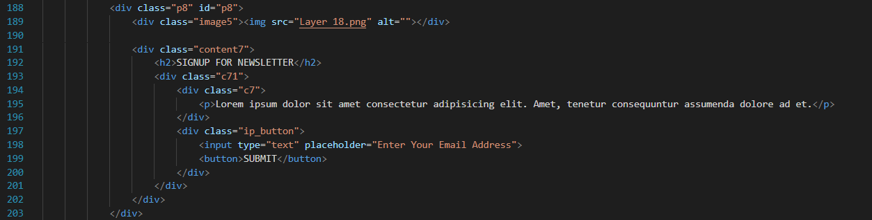

**-- DIV9(page9)—**

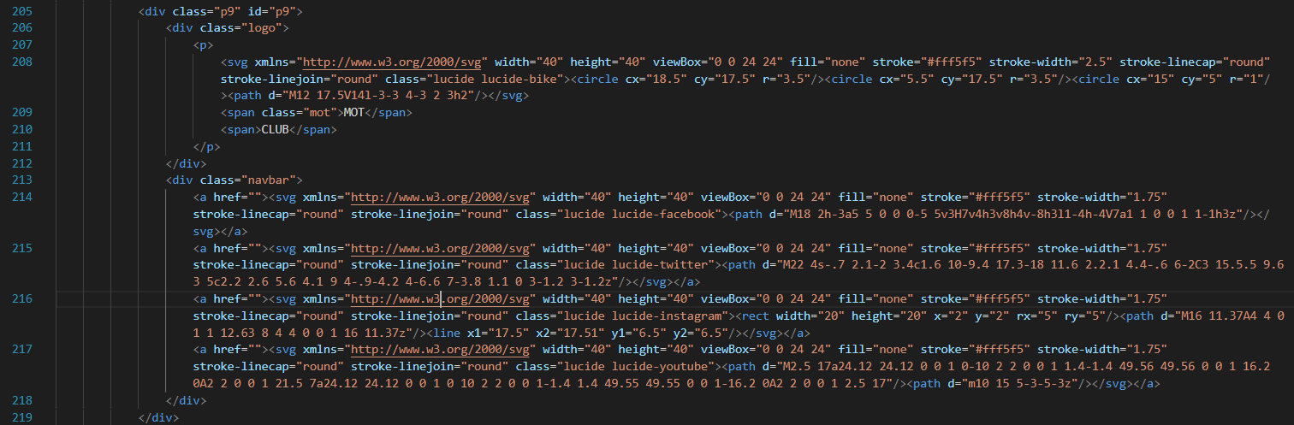

**-- DIV10(about us and contact info)—**

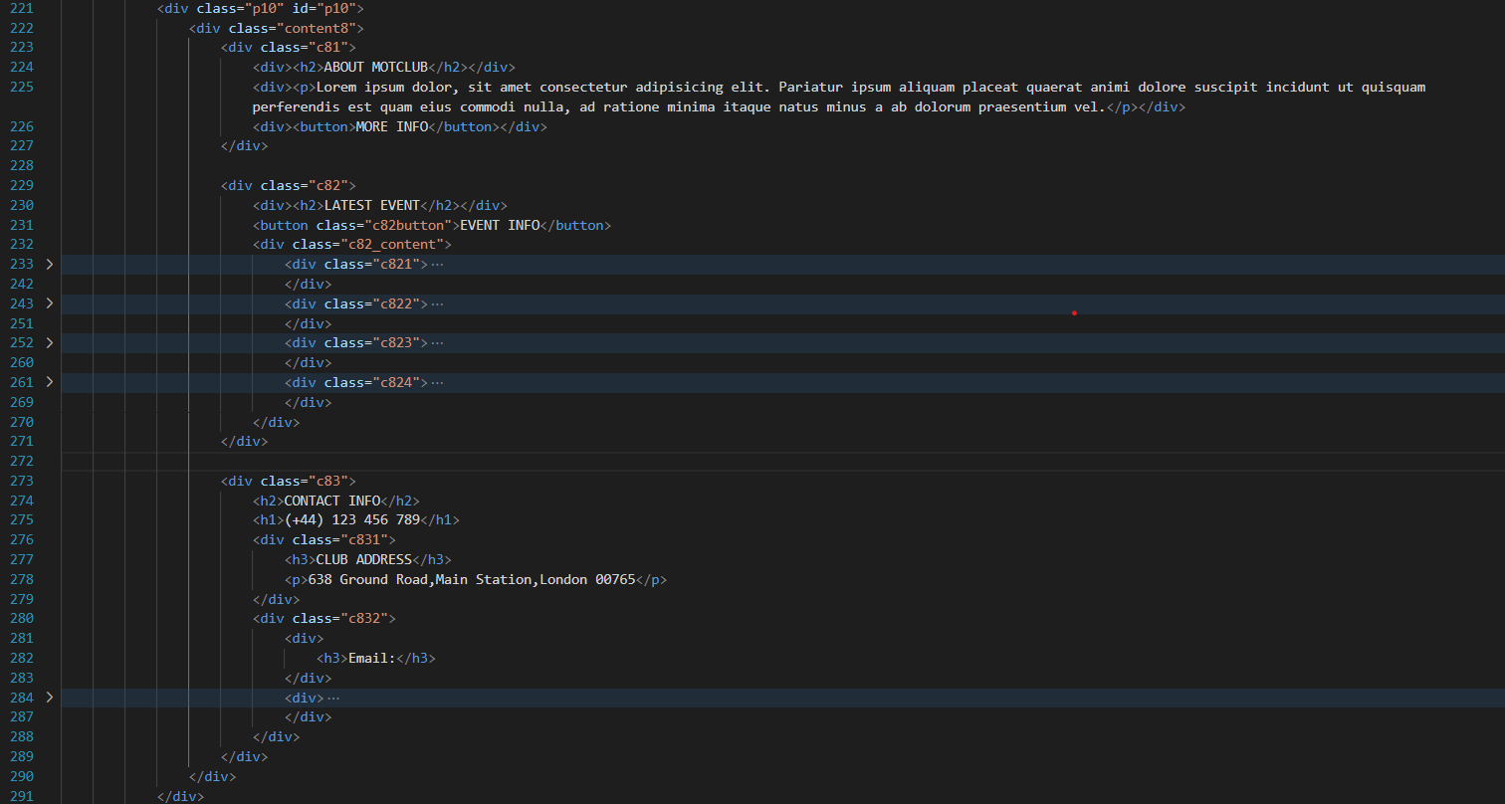

**-- FOOTER—**



**--CSS CODE—**

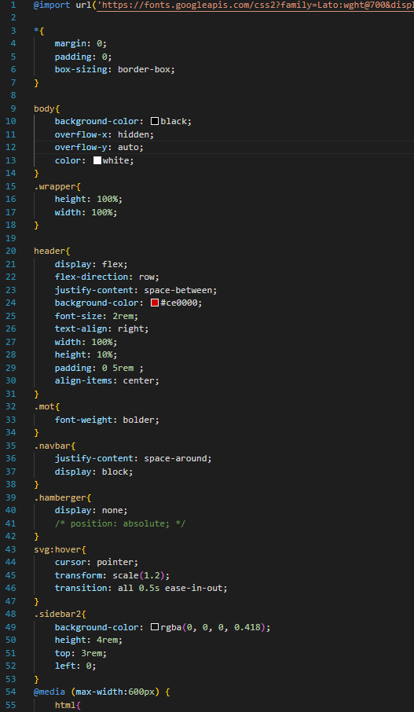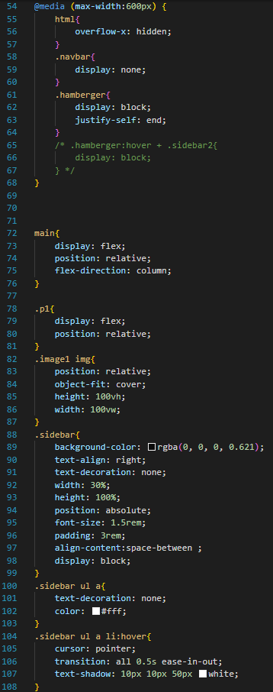

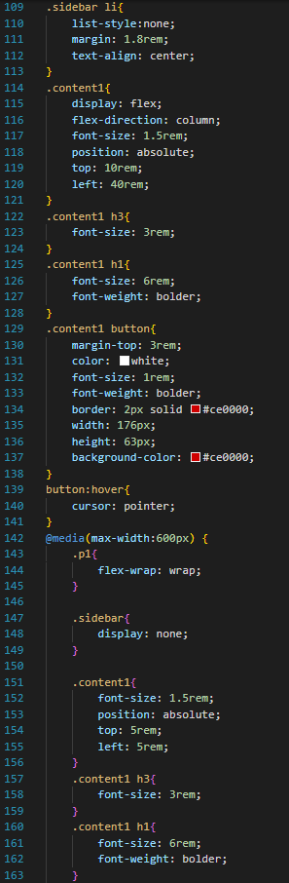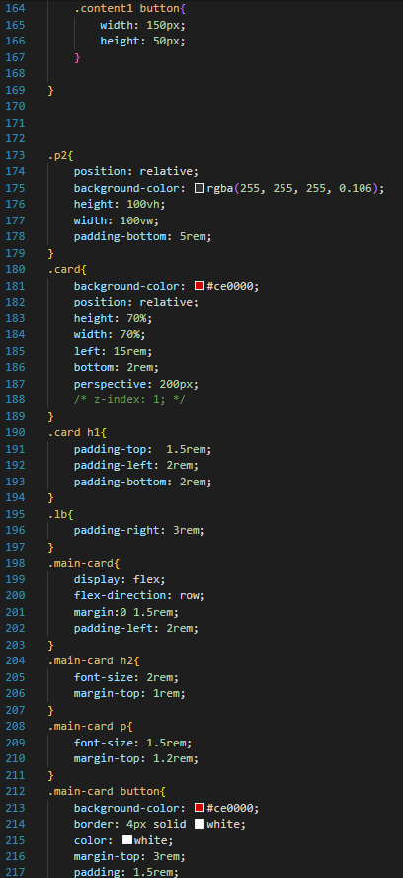

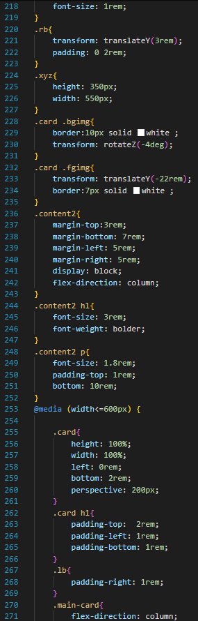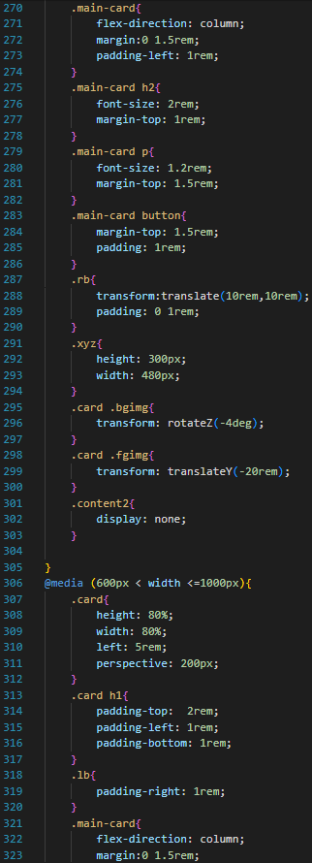

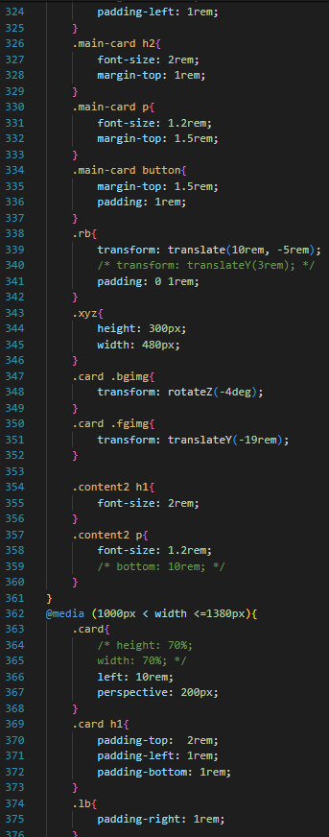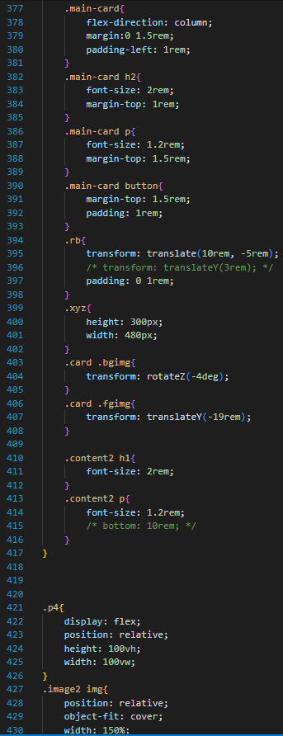

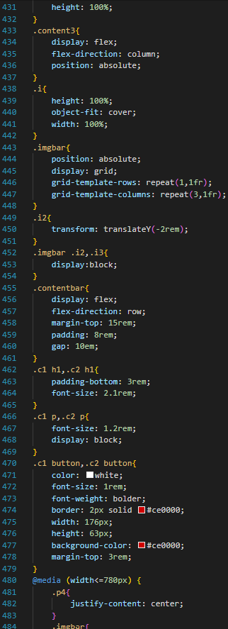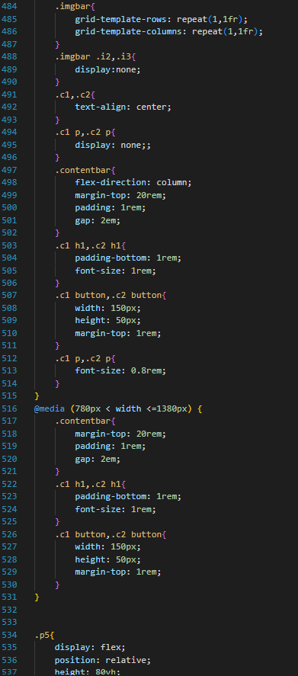

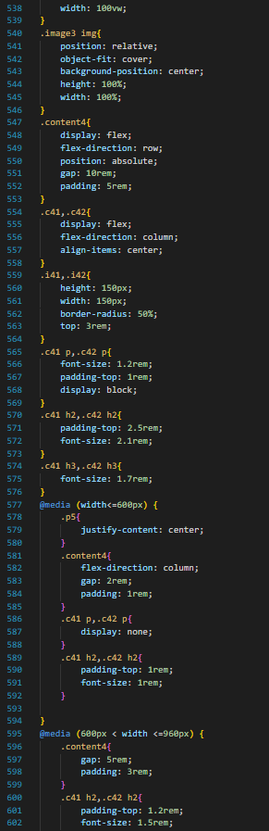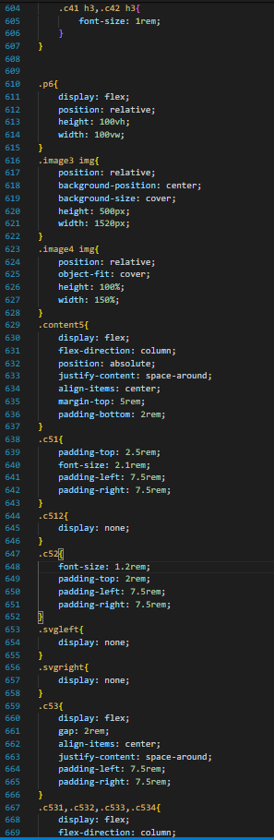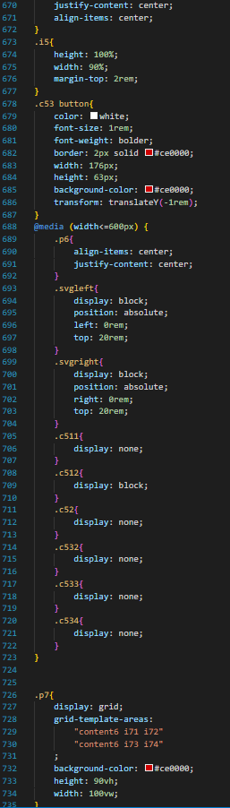

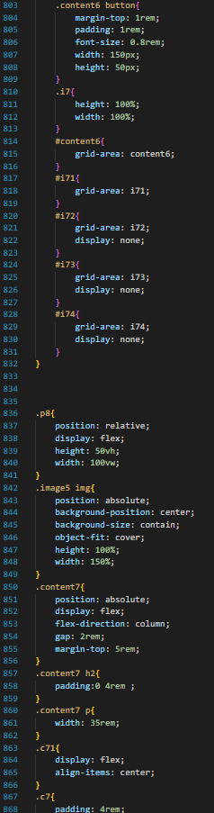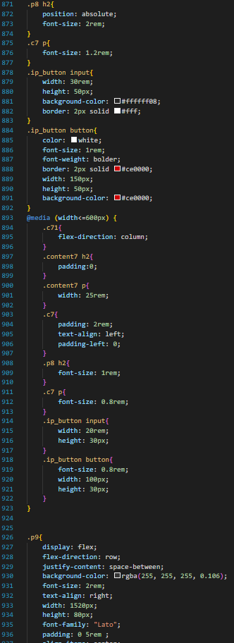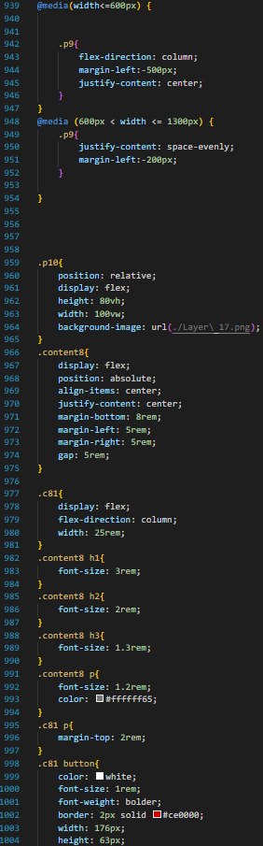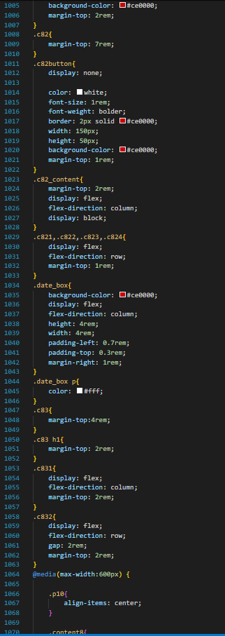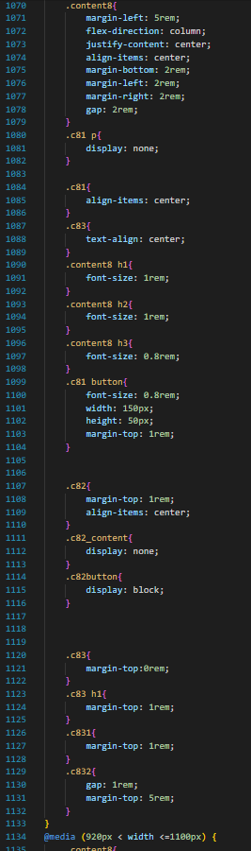

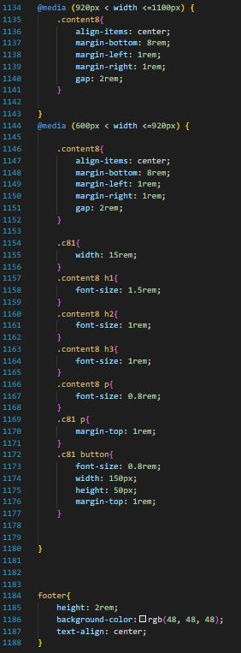

**--JS CODE—**

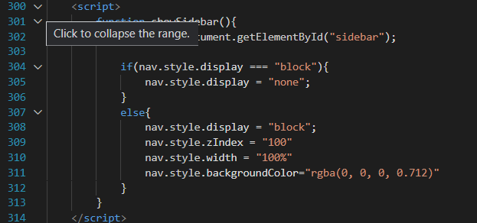

**REFERENCES**

1. www.photopea.com
2. [www.w3schools.com](http://www.w3schools.com)
3. [www.psdFreebies.com](http://www.psdFreebies.com)
4. https://fonts.google.com